Activity 5 - R Programming - Loops 2

Aryan Khandelwal

3/10/2022

1. Let’s write while loops to practice using the while loops.
2. Suppose you went to Vegas and you will bet until you are broke. You start with $100 and bet $1 each time for the slot machine, and you want to keep track of the money you had after each bet. The probability of winning is 1/216 for getting three jokers. Once you win, you earn $30. Write a while loop to simulate this. Also, set the seed number equal to 3000 in order to reproduce your simulation result. Show the money after first 6 bets on the screen after this is done.

money = c()  
money[1]<-100  
set.seed(3000)  
while(min(money)>0){  
 result<-sample(c(-1,30),size=1,prob=c(1-1/216,1/216))  
 money<-c(money, tail(money,1)+result)  
}  
plot(money, type = "l")

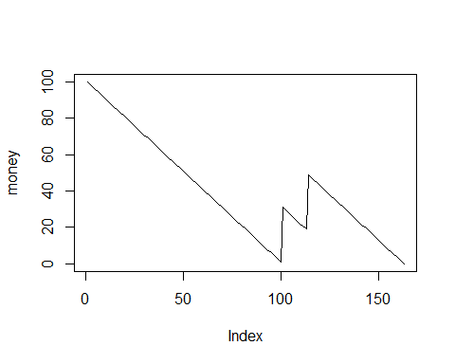

head(money)  
## [1] 100 99 98 97 96 95  
money[7]  
## [1] 94

1. This time, you shall simulate a different case. If you get any single joker, you earn $1 and the probability to win is 75/216. Same as before, you will bet until you are broke and each bet costs $1. Write a while loop to simulate this. Also, set the seed number equal to 3000 in order to reproduce your simulation result. Show the money after the last 6 bets on the screen after this is done.

money = c()  
money[1]<-100  
set.seed(3000)  
while(min(money)>0){  
 result<-sample(c(-1,1),size=1,prob=c(1-75/216,75/216))  
 money<-c(money, tail(money,1)+result)  
}  
plot(money, type = "l")

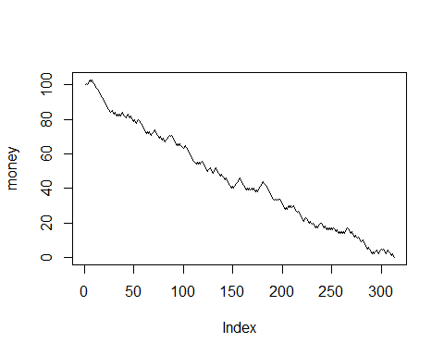

tail(money)  
## [1] 3 2 1 2 1 0